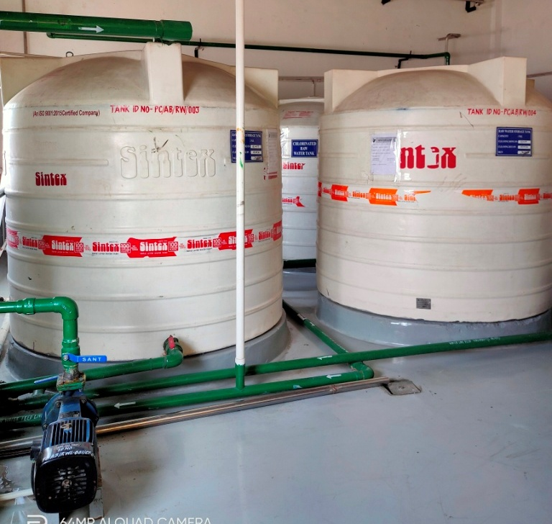 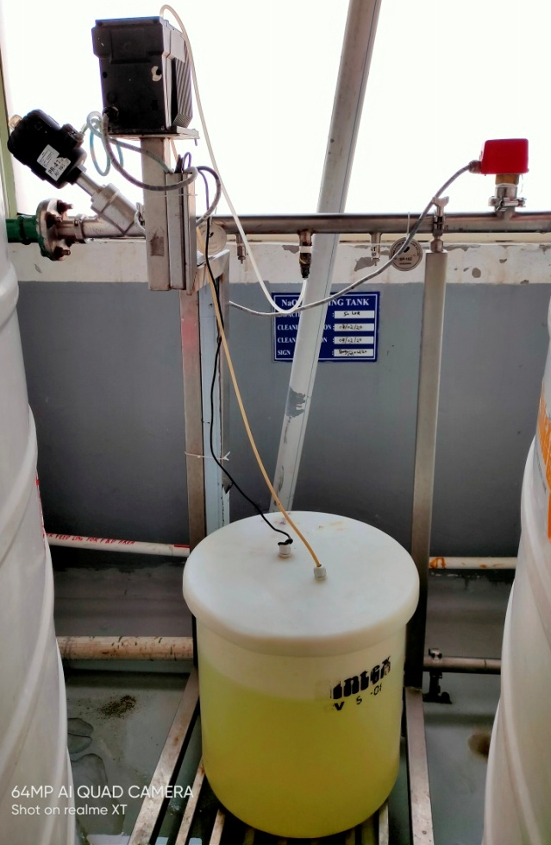

**Step 1:** Raw water stored in HDPE storage tanks **Step 2:** NaoCl dosing for Chlorination

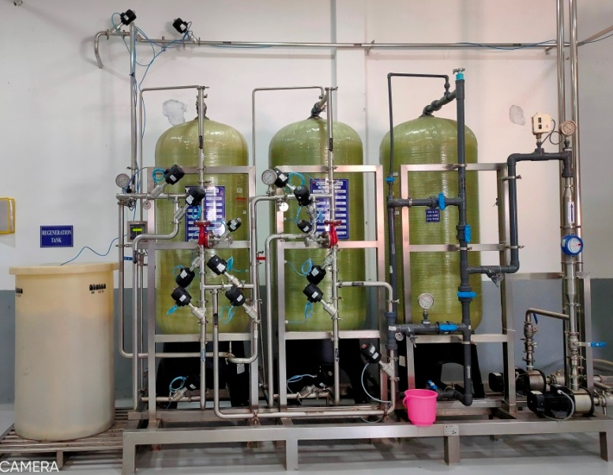 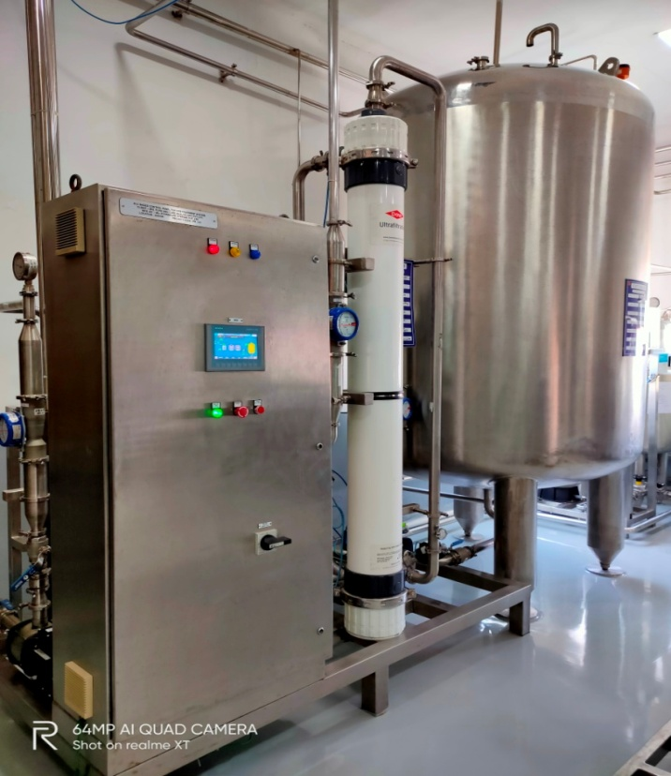

**Step 3:** Raw water passes through Multi-grade filter **Step 5:** Soft water is passed through 150 µ cartridge

**Step 4:** Further raw water passes through Softener filter

**Step 6:** Soft water then passed through Ultra-

filtration.

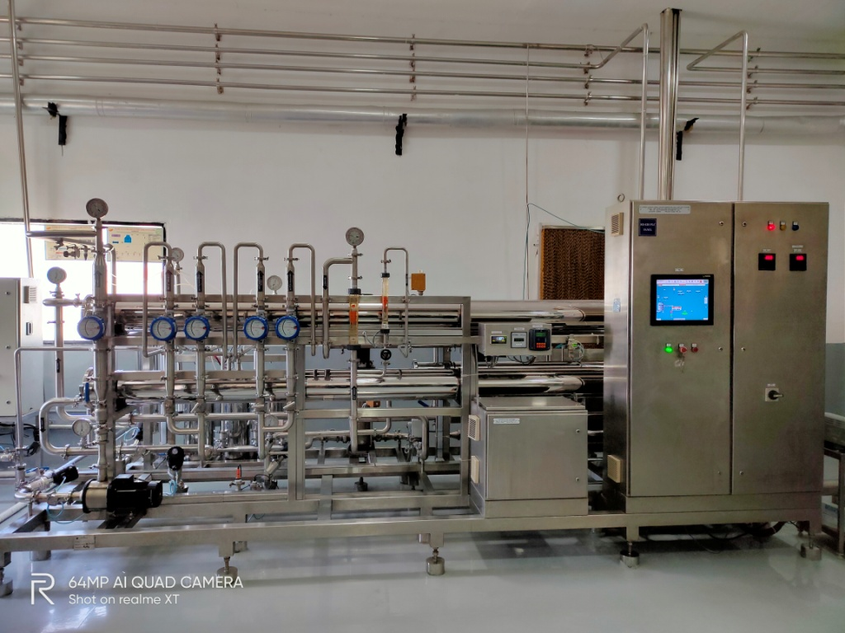

**Step 7:** Dosing of Anti-descalant, NaOH & Sodium metabisulphite done at this stage.

**Step 8:** Raw water is passed through 5µ filter**.**

**Step 9:** Water further passes through double RO membrane.

**Step 10:** After RO, the raw water passes through Electro Deionization & converted to Purified water.

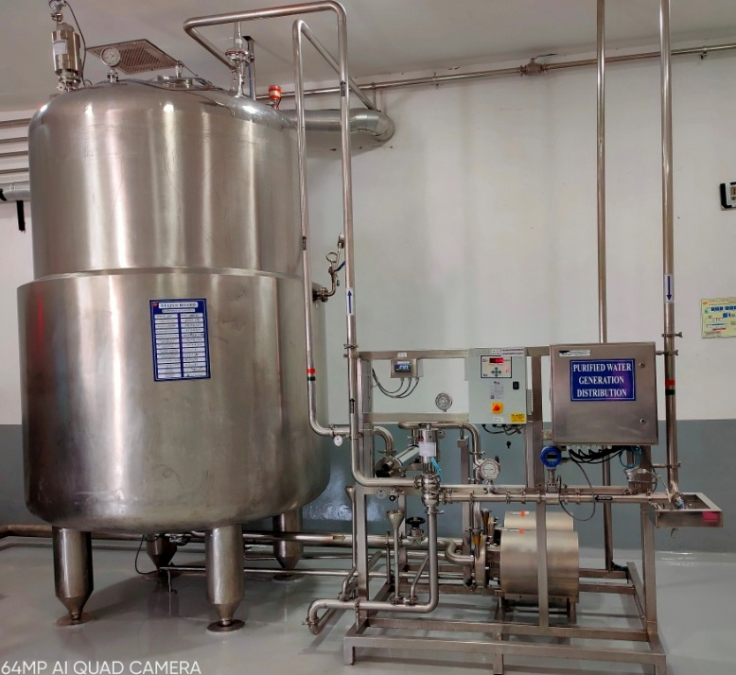

**Step 11:** Purified water now distributed to different user points.