VALIDATION PLAN

FOR

COMPUTER SYSTEM OF

HPLC

|  |  |
| --- | --- |
| **System Name** | **HPLC** |
| **System ID** |  |
| **Location** | **Instrument Lab** |
| **Effective Date** |  |

TABLE OF CONTENTS

1. PREPARATION AND APPROVALS 3

2. SIGNATURE OF EXECUTOR 4

3. REVISION HISTORY 4

4. OBJECTIVE 4

5. SCOPE 5

6. SYSTEM DESCRIPTION 5

7. ROLE AND RESPONSIBILITY 6

8. REFERENCES 7

9. DOCUMENTATION PROCEDURE 7

10. QUALIFICATION COMPLETION AND APPROVAL 8

11. ACCEPTANCE CRITERIA 8

12. DOCUMENTATION MANAGEMENT 8

13. REFERENCE DOCUMENTS 9

14. V-MODEL OF GAMP 9

15. VALIDATION APPROACH 10

16. CATEGORIZATION OF THE CONTROL SYSTEM 11

17. DOCUMENT SCOPE 11

17.1 Risk Assessment 12

17.2 Installation Qualification 12

17.3 Operational Qualification 13

17.4 Performance Qualification 14

17.5 Traceability Matrix 15

17.6 Validation Summary Report 15

18. CHANGE CONTROL 15

19. MAINTENANCE AND SUPPORT 16

20. STANDARD OPERATING PROCEDURE 16

21. DISCREPANCIES HANDLING DURING COMPUTER SYSTEM QUALIFICATION 16

22. APPROVAL AND DELIVERABLES 18

23. ABBREVIATION 19

# PREPARATION AND APPROVALS:

The signature listed below indicates the preparation and approval of this Validation Plan. This approval is joint responsibility of listed functional areas.

|  |  |
| --- | --- |
| **document development** | **SIGN / DATE** |
| **Name : __________________**  **Designation : __________________** |  |

|  |
| --- |
| **document review and APPROVAL (M/S ……………..)** |
| **Sign / Date : __________________**  **Name : __________________**  **Designation : __________________**  **Engineering** |
| **Sign / Date : __________________**  **Name : __________________**  **Designation : __________________**  **IT** |
| **Sign / Date : __________________**  **Name : __________________**  **Designation : __________________**  **Quality Control** |

|  |
| --- |
| **document APPROVAL (M/S ………………)** |
| **Sign / Date : __________________**  **Name : __________________**  **Designation : __________________**  **Quality Assurance** |

# SIGNATURE OF EXECUTOR:

All the executer involved in these documents have to sign within prescribed format given below.

**M/s ………….**

|  |  |  |  |  |
| --- | --- | --- | --- | --- |
| **Name** | **Designation** | **Signature** | **Initial** | **Date** |
|  |  |  |  |  |
|  |  |  |  |  |

**M/s ……………**

|  |  |  |  |  |
| --- | --- | --- | --- | --- |
| **Name** | **Designation** | **Signature** | **Initial** | **Date** |
|  |  |  |  |  |
|  |  |  |  |  |

# REVISION HISTORY:

|  |  |  |
| --- | --- | --- |
| **Date** | **Supersedes** | **Reason for Revision** |
|  |  |  |
|  |  |  |

# OBJECTIVE:

The objective of Validation Plan is to provide an organization approach towards the validation activities for the Computer System hardware and software of QC Department HPLC. This document will define the requirement and standards that must be followed for all the validation activities as apply to the Computer System of HPLC.

# SCOPE:

This document is applicable to validation of Hardware and Software system of Computer System (HPLC). This document shall define the test procedures, documentation, references and acceptance criteria in accordance with the guidelines laid down by the manufacturer of the system.

# SYSTEM DESCRIPTION:

Computer system of HPLC defines the controlling of analytical instrument connected to the system. It controlled the process of instrument connected to it by the software installed in the CS. The operator interface is carried out by CS screen. The CS is used to feed required parameters and set points in the system during operation. The system is connected to data server for printing and data backup. The system is secured by IT through password only within the system.

# ROLE AND RESPONSIBILITY:

The validation team comprising of representative from each of the following departments should be responsible for overall compliance with this validation plan.

|  |  |
| --- | --- |
| **Department** | **Responsibilities** |
| Validation Agency  (………….) | * To collect the necessary data for qualification activities. * To prepare the Validation Plan, Risk Assessment, Installation Qualification, Operational Qualification, Traceability Matrix and Validation Summary Report. * To execute the qualification in coordination with engineering, validation and quality assurance team. * Comply with regulatory / Guidelines / Standards / validation plan requirements throughout the validation life cycle. * To submit qualification for approval. |
| Engineering  (M/s. ………) | * To provide the necessary data for system requirement specification activities. * To review Validation Plan. |
| IT  (M/s. ………) | * To provide the necessary data for system requirement specification activities. * To review Validation Plan. |
| Quality Control  (M/s. ………..) | * To provide the necessary data for system requirement specification activities. * To review Validation Plan. |
| Quality Assurance  (M/s. ……….) | * To approve and authorized the Validation Plan. |

# REFERENCES:

The publication listed below form part of this reference documents. Each publication shall have latest revision in effect on the date of this document is approved for execution.

|  |  |
| --- | --- |
| **GAMP 5** | Good Automated Manufacturing Practices, Version 5, Guideline Document for Automated Systems from International Society of Pharmaceutical Engineering |
| **21 Code of Federal Regulations (CFR), Part 210** | Current Good Manufacturing Practice in Manufacturing, Processing, Packing, or Holding off Drugs; General |
| **21 Code of Federal Regulations (CFR), Part 211** | Current Good Manufacturing Practice for finished Pharmaceuticals |
| **21 Code of Federal Regulations (CFR), Part 11** | 21 Code of Federal Regulations (CFR), Part 11Electronic Records, Electronic Signatures, Final Rule Electronic Submissions; Establishment of Public Docket, Notice |
| **ICH Q9** | International Conference of Harmonization (ICH) quality risk assessment Q9 |
| **EU GMP** | Laying down the principles and guidelines of GMP in respect of medicinal products for human use. |
| **WHO** | Appendix 5, validation of computerized systems. |

# 

# DOCUMENTATION PROCEDURE:

* Qualification activities will be performed as defined in the approved document.
* All documentation will be completed during the execution of the qualification.
* Recording of information will be made in permanent ink.
* Fill out complete information in the verification table provided.
* Do not keep any space blank. Mark blank space with a single line throughout the appropriate space with mentioning NA (Not Applicable) and put initial and date.
* Correct the mistakes by drawing a single line through the incorrect data, recording the correct information and then initial sign and date the change.

# QUALIFICATION COMPLETION AND APPROVAL:

* Verify that all tests required by qualification are completed and attached.
* Verify that all amendments and discrepancies are documented, approved and attached.
* If all items in the qualification for the Computer System of HPLC have been reviewed and found to be acceptable, sign the corresponding block in the qualification completion and approval form.

# ACCEPTANCE CRITERIA:

* Installation completion as per manufacturer’s recommendations & cGMP requirements.
* The supply of all necessary documentation from manufacturer/Installer.
* The system is operating as intended and is under state of control.
* Operational features meet system requirements and system specifications.

# DOCUMENTATION MANAGEMENT:

All quality and project relevant documents delivered by ……. are handled through …….’s document management system. Each document has a unique ID and is version. The identification number of a document has the following structure:

<………..>-<Project No.>-<Document Name>-Version

The author’s name, the file name, the document number (document code and Revision No.) and the total pages number are included in the document footer in order to clearly assign each page to a certain document.

# REFERENCE DOCUMENTS:

1. Standard operating procedures
2. System requirement specifications

* System operation manual
* System bill of material

# V-MODEL OF GAMP:

The system development life cycle is based on the GAMP-5 development life cycle and the ISPE baseline for validation.

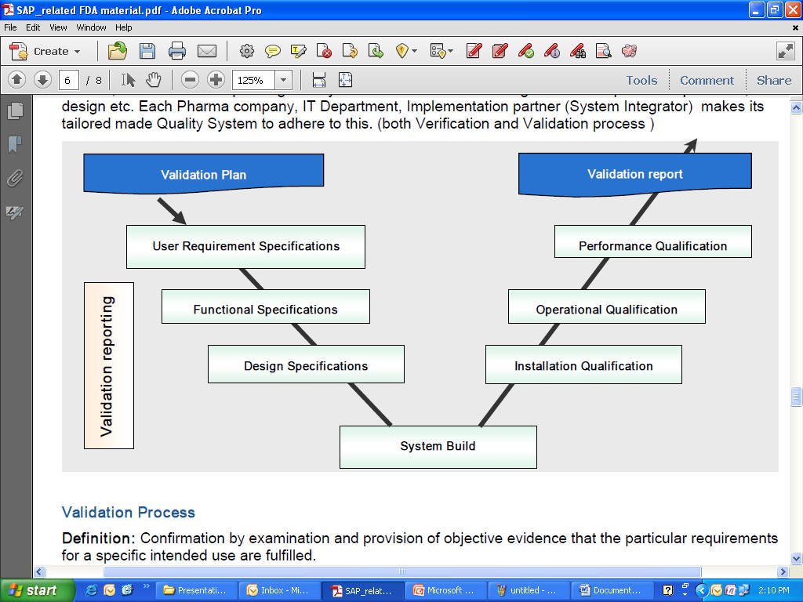

# VALIDATION APPROACH:

For the validation, GAMP 5 guidelines have been considered. As per GAMP Software Life Cycle approach is considered for all automated control systems. The following table depicts categorization of various software systems as per GAMP 5.

The system categorization is intended to evaluate and determine appropriate validation activities and deliverables. Once a system is evaluated as a whole, the functionality of individual components can be assessed for potential risk to data integrity and tested accordingly.

In determining the system categorization, functionality and intended use of the system are to be considered.

|  |  |  |
| --- | --- | --- |
| **Category** | **Software Type** | **Validation Approach** |
| 3 | Non-configured Software  e.g. Firmware based application  COTS software  Instruments | * Abbreviated Lifecycle approach * Risk based approach to supplier assessment * Record version (and configuration of environment) and verify correct installation. * Risk based tests against requirements. (calibrations for instruments) * Procedures in place for maintaining compliance and fitness for intended use. |
| 4 | Configurable Software Packages, e.g.  DAS  IPC  ERP  DCS  BMS  LIMS  HMI | * Life Cycle approach * Risk based approach to supplier assessment. * Record version number, verify correct installation * Risk based testing to demonstrate applicable works as designed in a test environment and within the business process. * Procedure in place for maintaining compliance and fitness for intended use. * Procedures in place for managing data. |
| 5 | Custom Software e.g. internally or externally developed IT applications.  Custom ladder logic  Spreadsheets (macro) | Same as configurable, plus:   * More rigorous supplier assessment. * Possession of full life cycle documentation * Design and source code review |

# CATEGORIZATION OF THE CONTROL SYSTEM:

**16.1 Computer System:**

The Computer control system falls under the **Category-3** Non-configurable software package as defined by **GAMP-5** guidlines. hence, verification & configuration and testing of operation against user requirement will be performed.

**16.2 Hardware CategoryAnd Software Category:**

* Hardware Category 1 - Standard hardware component
* Hardware Category 2 - Custom built hardware component

|  |  |  |
| --- | --- | --- |
| **Category** | **GAMP-4** | **GAMP-5** |
| 1 | Operating Software | Infrastructure Software |
| 2 | Firmware | No longer used |
| 3 | Standard Software | Non configured Software |
| 4 | Configurable Software | Configured Software |
| 5 | Custom Software | Custom Software |

# DOCUMENT SCOPE:

The documents scope of this validation plan is to establish the project framework for carrying out quality assurance and project management measures impacting ……… and M/s …………. for the project as described. The documents scope should define the activities to be performed, which will perform them, the control mechanisms to be used and the deliverables

* Validation Plan
* System Requirement Specification
* Risk Assessment Protocol
* Installation Qualification
* Operation Qualification
* Performance Qualification
* Traceability Matrix
* Validation Summary Report

## Risk Assessment:

|  |  |
| --- | --- |
| **Definition** | This document is to provide the analyses the risk of utilization of the Computer Systemof HPLC as per the cGMP and GxP and to identify the possible areas of risk , where the existing laid down appropriate controls or measures requires further strengthening. To suggest suitable solutions (action plan) to mitigate or minimize the risk. |
| **Phase** | Designing |
| **Control** | Review |
| **Executor** | Validation Team |
| **Prerequisites** | SRS is approved |
| **Acceptance** | M/s ………. |
| **Outcomes** | Risk Assessment |

## Installation Qualification:

|  |  |  |  |  |  |  |  |  |  |  |  |  |  |
| --- | --- | --- | --- | --- | --- | --- | --- | --- | --- | --- | --- | --- | --- |
| **Definition** | The objective of the installation qualification test is to verify the Computer System of HPLC installed at the M/s …………...  This includes the following tests:   |  | | --- | | * Identification of  System Details | | * Verification of Master Documents for computer system | | * Verification of capacity Requirement of computer system | | * Verification of Hardware Components | | * Verification of Software Components | | * Verification of Physical and Logical Security Control | | * Verification of Test Instruments Calibration and it’s Traceability | | * Verification of Power Supply | | * Verification of Environmental Condition | | * Verification of Communication Link Between Server To Computer System | | * Verification of General System Installation | | * Verification of Standard Operating Procedures | |
| **Phase** | Commissioning |
| **Control** | Review |
| **Executor** | Validation Team |
| **Prerequisites** | Risk Assessment is Pre approved |
| **Acceptance** | M/s ………… |
| **Outcomes** | Installation Qualification |

## 

## Operational Qualification:

|  |  |  |  |  |  |  |  |  |  |  |  |  |  |  |
| --- | --- | --- | --- | --- | --- | --- | --- | --- | --- | --- | --- | --- | --- | --- |
| **Definition** | The objective of the operational qualification test is to verify the function of Computer System of HPLC installed at the M/s …………..  This includes the following tests:   |  | | --- | | * Verification of Field Instrument Calibration | | * Verification of Windows Security | | * Verification of System Start-up & Shutdown | | * Verification of Password Security | | * Verification of User access and security features of the system | | * Verification of Application software Screens. | | * Verification of System Response Failure. | | * Verification of Electronic Data Security. | | * Verification of Audit Trail. | | * Verification of Report Generation. | | * Verification of User Prevented From Alternating Date and Time. | | * Verification of Data Back Up. | | * Verification of system software as per 21 CFR part 11 Clauses. | |
| **Phase** | Commissioning |
| **Control** | Review |
| **Executor** | Validation Team |
| **Prerequisites** | Risk Assessment is Pre approved |
| **Acceptance** | M/s ……….. |
| **Outcomes** | Installation Qualification |

## Performance Qualification:

|  |  |  |
| --- | --- | --- |
| **Definition** | The objective of the performance qualification test is to verify the function of Computer System of HPLC installed at the M/s ………….  This includes the following tests:   |  | | --- | | * Verification of Control Loops Test | |
| **Phase** | Commissioning |
| **Control** | Review |
| **Executor** | Validation Team |
| **Prerequisites** | Operational Qualification is approved |
| **Acceptance** | M/s …………… |
| **Outcomes** | Performance Qualification |

## Traceability Matrix:

|  |  |
| --- | --- |
| **Definition** | The traceability matrix is to provide the assurance that mapped between IQ and OQ. The traceability matrix contains all the traceability mentioned in system requirement specifications. |
| **Phase** | Commissioning |
| **Control** | Review |
| **Executor** | Validation Team |
| **Prerequisites** | SRS, IQ and OQ is approved |
| **Acceptance** | M/s ………….. |
| **Outcomes** | Traceability Matrix |

## Validation Summary Report:

|  |  |
| --- | --- |
| **Definition** | This validation summary report is to collect sufficient data and the qualification executed pertaining to the Computer Systemof HPLC.Successful completion of this document will provide the successfully validated of the Computer Systemof HPLC.This report describes the successful validation qualification for the Computer Systemof HPLC. |
| **Phase** | Commissioning |
| **Control** | Review |
| **Executor** | Validation Team |
| **Prerequisites** | IQ and OQ is approved |
| **Acceptance** | M/s …………… |
| **Outcomes** | Validation Summary Report |

# 

# CHANGE CONTROL:

All changes in the control system during the validation activities shall be handled as per the change control SOP.

# MAINTENANCE AND SUPPORT:

The Computer System of HPLC and its associated components shall be incorporated into the planned preventive maintenance activities. Any software changes, which shall be required and any upgrades in hardware and operating system software shall be carefully controlled and all documentation maintained as per prevailing change control procedures.

# STANDARD OPERATING PROCEDURE:

A number of SOP’s will be developed for the operations that support the control systems during this validation exercise. Each SOP is listed below.

* System Security
* Desktop Policy for Computer Operated
* Data Backup, Archiving and Retrieval
* Change Control
* Software in Laboratory and GMP System
* System operation

# DISCREPANCIES HANDLING DURING COMPUTER SYSTEM QUALIFICATION:

* In case of discrepancy observed during qualification, document in the defined column in each table and document the details of the observation in the discrepancy log sheet.
* Inform to engineering IT and quality assurance about discrepancy.
* Investigate the discrepancy and ensure the possible impact.
* If discrepancy does not have potential to impact on operation as well as performance of the system, close the discrepancy with proper justification.
* The engineering, IT and QA will decide whether discrepancy is acceptable or not.
* If discrepancy is acceptable, provide conclusion and recommendation if any into respective column.

**DISCREPANCY AND CORRECTIVE ACTION FORM:**

|  |  |
| --- | --- |
| Protocol Reference |  |
| Discrepancy Number |  |

**DISCREPANCY:**

|  |  |
| --- | --- |
| Describe the Discrepancy | |
|  | |
|  | |
|  | |
| Reported by | Date |

**CORRECTIVE ACTION:**

|  |  |
| --- | --- |
| Describe corrective action taken (Attach additional sheets if necessary) | |
|  | |
|  | |
|  | |
| Reported by | Date |

**DISPOSITION ACTION:**

|  |  |  |  |  |
| --- | --- | --- | --- | --- |
| Acceptable? | Yes | No |  | |
| Discussion | | | | |
|  | | | | |
|  | | | | |
|  | | | | |
| Approved by | | | | Date |

**COMPLETION:**

|  |  |
| --- | --- |
| Completed by | Date |

# APPROVAL AND DELIVERABLES:

The complete validation is governed by a series of quality assurance measures. The following table lists the validation deliverables. It is assumed that all documents are submitted by ………. as required.

| **Deliverable** | **Original Location** | **Validation Agency**  **(Developer)** | **M/S …….. (Reviewer)** | **M/S ……. (Reviewer)** | **M/S …… (Reviewer)** | **M/S ……. (Approver)** |
| --- | --- | --- | --- | --- | --- | --- |
| **Validation Plan** | Validation Dept. | ……. | Engineering | IT | Quality Control | Quality Assurance |
| **System Requirement Specfication** |
| **Risk Assessment Protocol** |
| **Installation Qualification** |
| **Operational Qualification** |
| **Traceability Matrix** |
| **Validation Summary Report** |

# ABBREVIATION:

|  |  |
| --- | --- |
| **Abbreviations** | **Description** |
| GMP | Good Manufacturing Practices |
| SRS | SystemRequirement Specification |
| RA | Risk Assessment |
| IQ | Installation Qualification |
| OQ | Operation Qualification |
| PQ | Performance Qualification |
| QA | Quality Assurance |
| TM | Traceability Matrix |
| VSR | Validation Summary Report |
| SOP | Standard Operating Procedure |
| NA | Not Applicable |
| IO | Input Output |
| ICH | International Conference of Harmonization |
| CS | Computer System |
| ID | Identification |
| WHO | World Health Organization |